1)

Code for tables and images from database for insurance

DROP TABLE IF EXISTS claim

CREATE TABLE claim

(

Claim_ID_Number varchar(100) not null primary key,

Claim_Receipt_Date date not null default current_date,

Claim_Description varchar(255),

Claimant_Birth_Date date not null default current_date,

Law_Suit_Indicator char(10),

Claimant_First_Name varchar(255),

Claimant_Last_Name varchar(255),

Policy_Number varchar(150),

Claimant_Occupation varchar(255),

Loss_Date date not null default current_date,

Claim_Amount decimal(25,2),

Claim_Paid_Amount decimal(25,2) null,

Claim_Paid_Date date null default current_date

);

INSERT INTO claim

VALUES ('C123450000', '12/5/20', 'Automobile_accident', '8/1/75' , 'N' , 'Joe' , 'Smith', 'P987654321', 'Physician', '12/4/20', '5000.00',NULL, NULL),

('C123441000', '8/5/19', 'Automobile_accident', '8/1/75', 'N', 'Joe' , 'Smith', 'P987654321', 'Physician', '8/2/19', '7600.00', '7100.00', '9/5/19'),

('C123440000', '10/15/20', 'Robbery' , '3/20/86' ,'N', 'Mary', 'Roberts', 'P987654111', 'Not provided', '10/1/20', '25000.00', '20000.00', '11/5/20'),

('C345478900', '7/13/20' ,'Property', '5/27/90' ,'N' ,'Aditya', 'Reddy', 'P987654222', 'Business_Owner', '7/12/20', '10000.00', '8000.00', '8/12/20');

DROP TABLE IF EXISTS customer1;

CREATE TABLE customer1(

Customer_ID_Number varchar(100) not null primary key,

Customer_First_Name varchar(255),

Customer_Last_Name varchar(255),

Customer_Type varchar(150),

Business_Name varchar(255),

Address_Street_Name_Line_One varchar(255),

Address_City varchar(255),

Address_State varchar(255),

Address_Postal_Code varchar(100),

Address_Type varchar(100),

Customer_Birth_Date date ,

Risk_Score int

);

INSERT into customer1

VALUES(777543325, 'Mary', 'Roberts', 'Individual', NULL, '123 Main Street',NULL, 'Chicago', 'Illinois', 60007, 'Residential', '3/20/86',75) ,

(777543800, 'Joe', 'Smith', 'Individual', NULL, '123 Park Avenue',NULL, 'New York', 'New York', 10017, 'Residential', '2/27/63', 70),

(776983401, 'Aditya', 'Reddy', 'Business' ,'ABC Systems' ,'222 Hyde Street', 'Floor 2', 'San Francisco', 'California' ,94123 ,'Business', NULL ,50);

DROP TABLE IF EXISTS policy_detail;

CREATE TABLE policy_detail(

Customer_ID_Number varchar(100) not null,

Policy_Number varchar(100) not null,

Policy_Effective_Date date,

Policy_Expiration_Date date,

Policy_Limit decimal(15,2),

Policy_Type varchar(50),

Currency_Type char(3),

Premium_Cost decimal(25,2)

);

INSERT INTO policy_detail

VALUES

(777543800, 'P987654321', '2/11/20', '2/11/21', 500000.00, 'Automobile', 'USD',2600.00 ),

(777543800, 'P987654321', '2/11/19', '2/11/20', 500000.00, 'Automobile', 'USD', 2300.00),

(777543800, 'P987654321', '2/11/18', '2/11/19', 500000.00, 'Automobile', 'USD', 2150.00),

(777543800, 'P987654321', '2/11/17', '2/11/18', 500000.00, 'Automobile', 'USD', 2100.00),

(777543325, 'P987654111', '3/15/20', '3/15/21', 5000000.00,'Excess/Umbrella', 'USD', 5500.00),

(776983401, 'P987654222', '6/15/20', '6/15/20', 3000000.00, 'Property', 'USD' ,10000.00);

DROP TABLE IF EXISTS reserves;

CREATE TABLE reserves(

Customer_ID_Number varchar(100) not null,

Policy_Number varchar(100) not null,

reserved_Amount decimal(15,2),

reserved_date date not null,

primary key(reserved_date )

);

Insert into reserves

Values (777543325, 'P987654111', 5000.00, '3/15/20'),

(776983401, 'P987654222', 7000.00, '6/15/20'),

(777543800, 'P987654321', 1500.00, '2/11/17'),

(777543800, 'P987654321' ,1500.00, '2/11/18'),

(777543800, 'P987654321', 1500.00, '2/11/19');

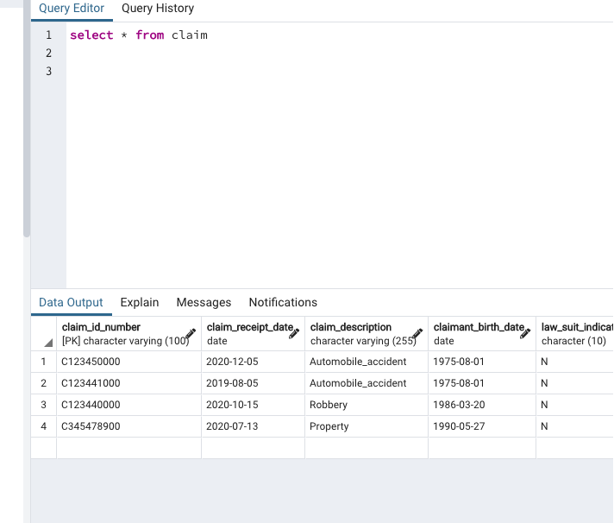

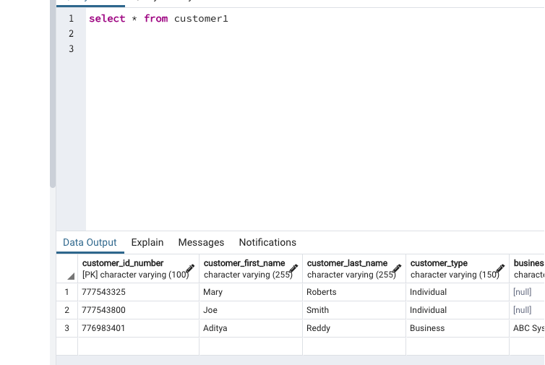

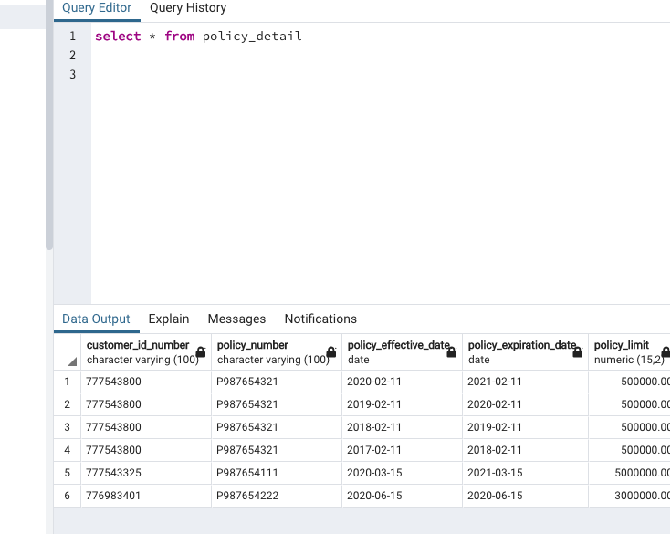

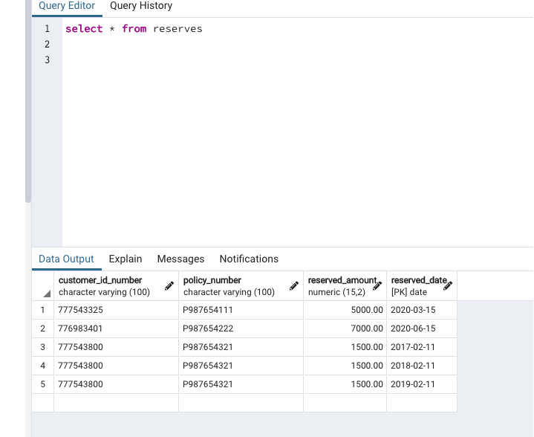

5 SQLS:

1. What is the customer id number who had a reserve date on 02/11/2019 ?

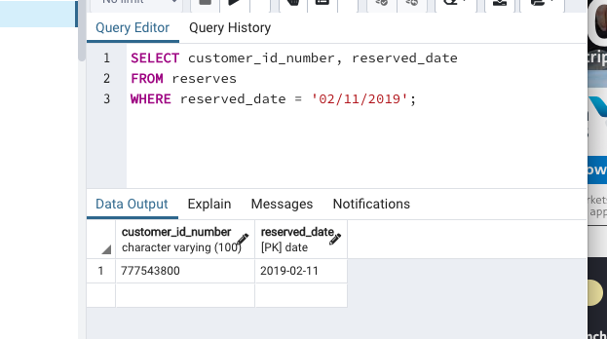

1. Find the highest policy limit.

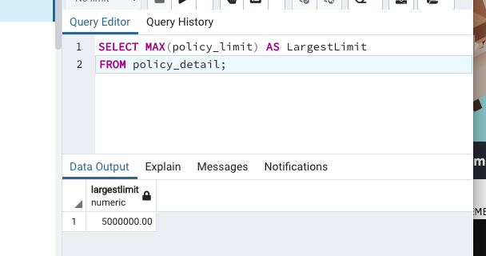

1. List how many claimants belong in each occupation listed in the claims table.

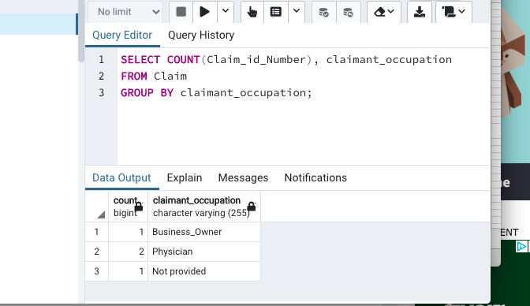

1. Find the total amount of paid claims that all claimants named Joe received.

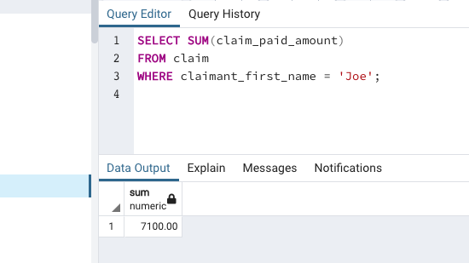

1. Find the common column on Customer1 Table and Reserves, and use the join command to join customer1 onto reserves.

